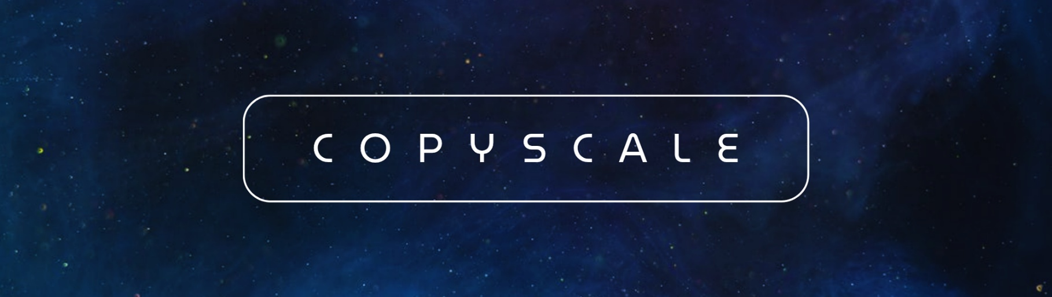

**Project Abstract**

**Copyscale** is an advanced AI-powered copyright protection platform that detects unauthorized usage of copyrighted content in AI training datasets. Leveraging multi-layer neural network analysis, the system provides forensic-level similarity detection across images and videos. By employing ResNet50 for deep feature extraction and cosine similarity metrics, Copyscale offers content creators, legal professionals, and media companies a robust tool to identify potential AI training data contamination and protect intellectual property rights in the rapidly evolving AI landscape.

**User Flow**

**Phase 1: Content Registration**

User Uploads Copyrighted Content → System Generates Digital Fingerprint →

Content Stored in Secure Database → Metadata Added (Title, Owner, Description)

**Phase 2: Analysis & Detection**

User Uploads Suspect Content → Multi-Layer Feature Extraction →

Three-Tier Similarity Analysis → Weighted Risk Scoring →

Comprehensive Report Generation

**Phase 3: Results & Action**

Risk Assessment Dashboard → Interactive Visualizations →

Detailed Similarity Metrics → Expert Analysis Notes →

Evidence for Legal Proceedings